**EXPERIMENT 11**

**PROCEDURES**

**Aim:**

• Create a table with attributes students and marks.

• Insert values into the table.

**create table pro(id int,marks int);**

**insert into pro(id,marks) values (1,30), (2,60),(3,50),(4,70);**

**select * from pro;**

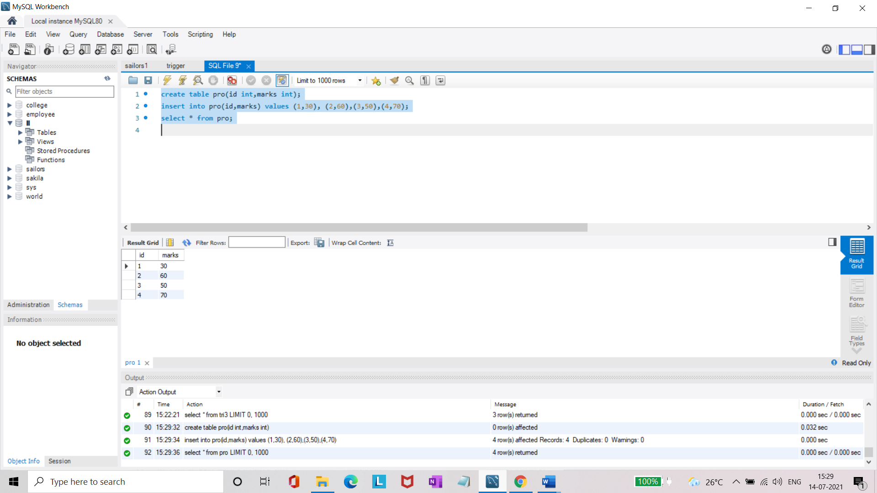

• Create a procedure to get the merit students (marks > 50).

**DELIMITER //**

**create procedure get_marks()**

**begin**

**select * from pro where marks>10;**

**select count(id) as total_students from pro;**

**end //**

**DELIMITER ;**

**call get_marks();**

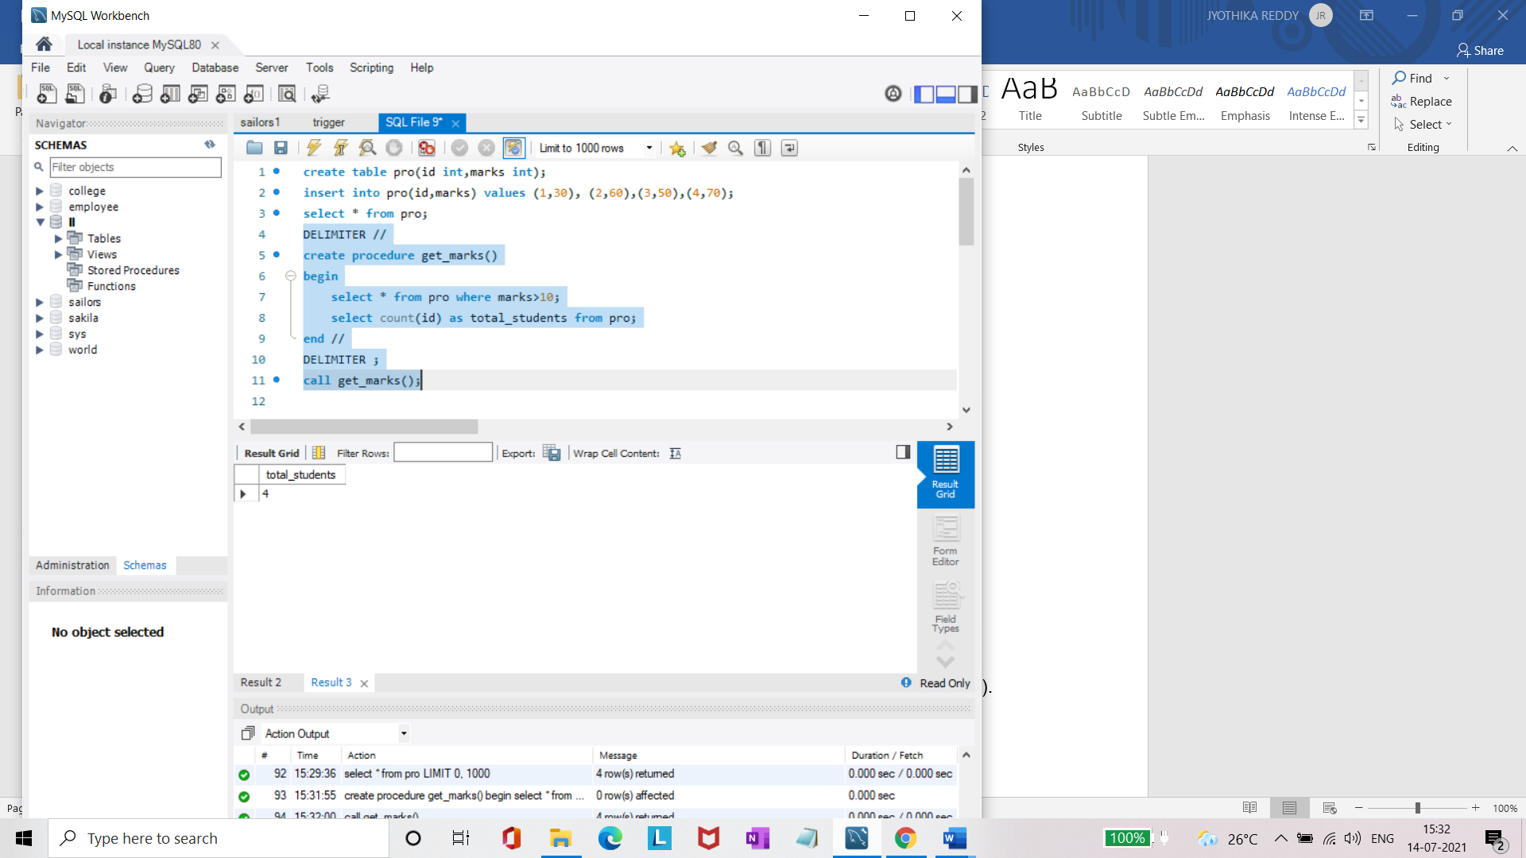

• Create a procedure to get marks of a given id (using in).

**(IN**

**DELIMITER //**

**create procedure get_mark(in id1 int)**

**begin**

**select * from pro where id=id1;**

**end //**

**DELIMITER ;**

**call get_mark(3);**

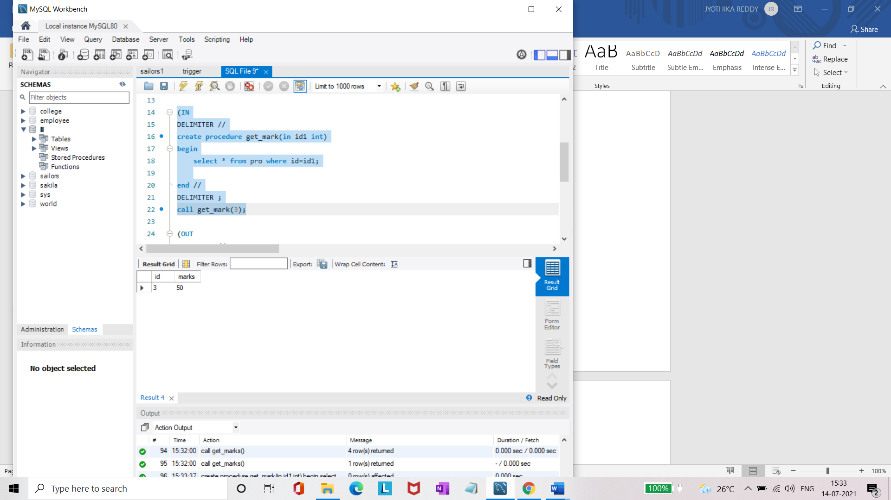

• Create a procedure to display highest marks (using out).

**(OUT**

**DELIMITER //**

**create procedure get_max_mark(out id2 int)**

**begin**

**select max(marks) from pro as max;**

**end //**

**DELIMITER ;**

**call get_max_mark(@id2 );**

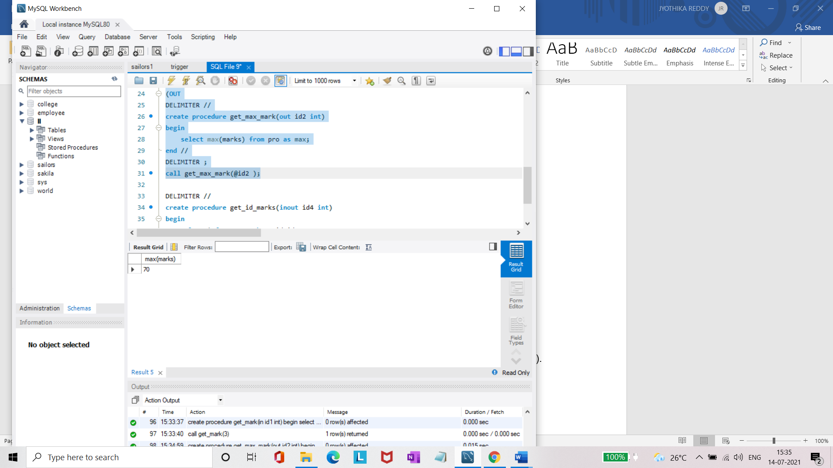

• Create a procedure to get marks of a given id (using in and out).

**DELIMITER //**

**create procedure get_id_marks(inout id4 int)**

**begin**

**select * from pro where id=id4 ;**

**end //**

**DELIMITER ;**

**set @m=3;**

**call get_id_marks( @m);**

